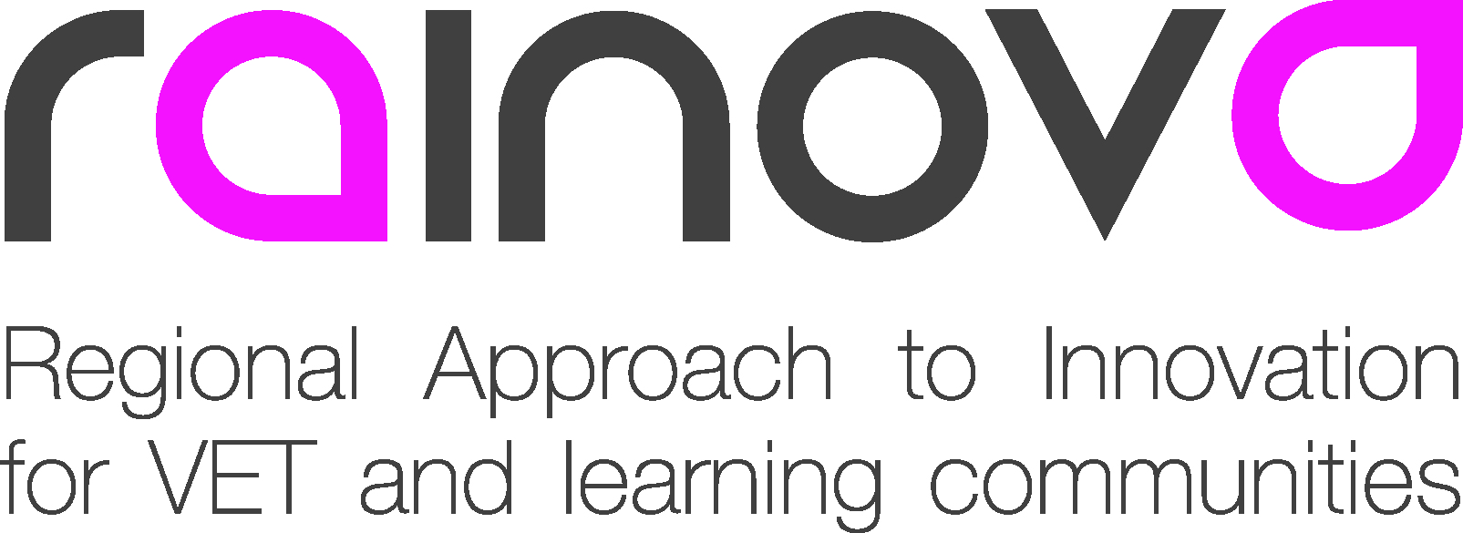 |  |  | 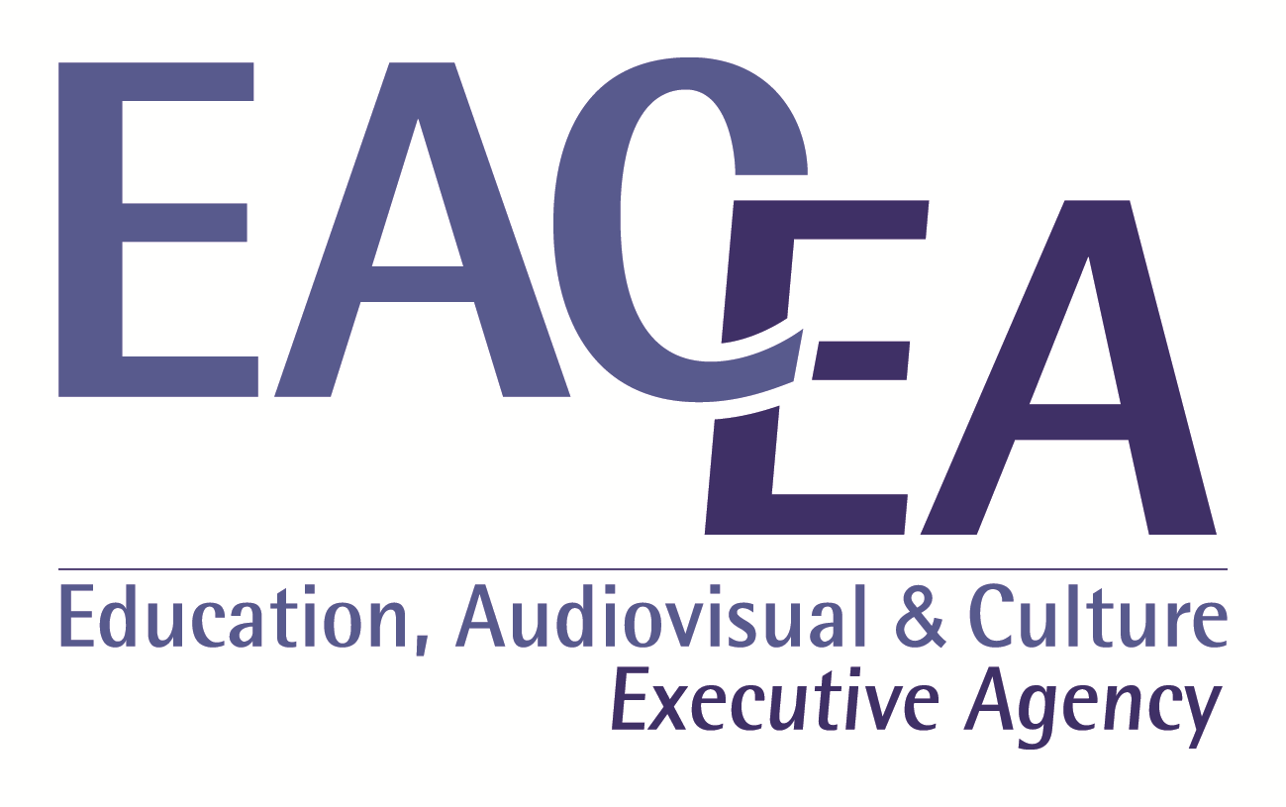

Project Number: 517752-LLP-1-2011-1-ES-LEONARDO-LNW

Project acronym: Rainova

Project title: Regional Approach to Innovation
for VET and Learning Communities

Deliverable reference number: D.1

Deliverable title: Project Management and Quality Plan.

Due date of deliverable: end of February 2012

Actual submission date: XXX

Start date of project: 1 January 2012 Duration: 36 months
Organisation name of lead contractor for this deliverable: IKASLAN

Project co-funded by the European Commission within the Lifelong Learning Programme (2012-2014)
Dissemination Level
PU | Public
PP | Restricted to other programme participants (including the EC services)
RE | Restricted to a group specified by the Consortium (including the EC services)
CO | Confidential, only for members of the consortium (including EACEA and Commission Services and project reviewers) | X

Table of Contents

1. Summary ...................................................................................................................... 03

2. Introduction ................................................................................................................. 03
2.1 Purpose and scope of the project management ......................................................... 03

3. Project organisation ................................................................................................... 04
3.1 Management structure ................................................................................................. 04
3.2 Management responsibilities ...................................................................................... 05
3.2.1 The Project Coordinator (CO) .................................................................... 05
3.2.2 The Quality Management Team (QMT) ..................................................... 05
3.2.3 Workpackage Leaders ............................................................................... 06
3.2.4 Description of a Partner’s task ................................................................... 06
3.3 Decision making .......................................................................................................... 06
3.3.1 Steering Committee ................................................................................... 06
3.3.2 General Assembly ...................................................................................... 07

4. Communication ........................................................................................................... 07
4.1 Rainova internal web site ............................................................................................ 07
4.2 Public website .............................................................................................................. 08
4.3 Distribution lists ........................................................................................................... 08
4.4 Teleconferencing ........................................................................................................ 09
4.5 Dissemination policy ................................................................................................... 09

5. Project Meetings ……………….................................................................................... 10
5.1 Types of meetings ....................................................................................................... 10
5.2 Meeting organisation ................................................................................................... 11
5.3 Responsibilities of the meeting participants ................................................................ 11
5.4 Meeting calling notice ................................................................................................. 11
5.5 Minutes ....................................................................................................................... 12

6. Document management ............................................................................................. 12
6.1.1 General rules ............................................................................................. 13
6.1.2 Document format ....................................................................................... 14

7. Production of deliverables ......................................................................................... 16
7.1.1 Deliverable structure .................................................................................. 17
7.1.2 Internal review and quality check ............................................................... 18

8. Reporting and progress monitoring ......................................................................... 18
8.1 Intermediate Management Reporting ......................................................................... 19
8.1.1 Resource consumption .............................................................................. 19
8.1.2 Progress monitoring .................................................................................. 19

9. Financial management ............................................................................................... 20
9.1 General Information .................................................................................................... 21
9.2 Preparation of Financial Statements and Certificates ................................................. 21

10. Risk management ..................................................................................................... 22
10.1 Definitions ................................................................................................................. 22
10.2 Risk management and responsibilities ..................................................................... 23
10.3 Risk management process ……………………………................................................ 24

11. Handling of changes ................................................................................................. 25

12. Conclusions .............................................................................................................. 26

13. Appendixes ................................................................................................................ 27
13.1 Appendix 1 - Timeline and Work Plan ....................................................................... 27
13.2 Appendix 2 - Intermediate Management Report Template .................................... 29
13.3 Appendix 3 - Internal website map …….................................................................... 29

14. Glossary ..................................................................................................................... 29

- Summary

This Rainova Project Management and Quality Plan describes the management and quality control procedures of the project, which are meant to facilitate co-operation within the consortium and assure the quality of the work carried out.

This document has the purpose to provide a set of practical guidelines to the consortium of the Rainova project.

The document sets up the working procedures and rules for the consortium partners, defines document templates and means of communication and control.

The recommendations it contains, if used with some discipline, will reduce the project overhead and ease the cooperative work of the partners, and it may therefore be considered crucial for overall success of the Rainova project.

In addition, these rules will ensure that the consortium meets all the obligations related to the contract with the EACEA. (Education, Audiovisual and Culture Executive Agency) (From now on the Agency)

The document is a complement to all other documents that the coordination team should have read and have access to while the project is running; the Grant Agreement (GA) and its annexes, the Consortium Agreement (CA) and the various guidelines.

2. Introduction

2.1 Purpose and scope of the Project Management and Quality Plan

The main objectives of this Project Management and Quality Plan are:

- To set up the management infrastructure.
- To provide technical and administrative assistance to the coordinator and to the partners.
- To provide financial and contractual management of the consortium and the related contractual documents.
- To negotiate any necessary changes to these agreements during the project.

The Rainova management structure is designed to reach the following objectives:

- Ensure timely and qualitative achievement of the project objectives.
- Coordinate at the consortium level the activities of the Rainova project.
- Provide decision making, quality control and conflict resolution mechanisms to manage the project’s consortium and its execution.
- Coordinate and provide interface for conjunct action with end-users, stakeholders and other European projects.
- Manage the activities of the project, especially those that need a strong co-ordination, for instance, field trials and dissemination activities.
- Manage implementation of changes in the activities and in the consortium.
- Provide timely and efficient financial and administrative coordination of the project.
- Coordinate and provide interface with the Agency.

The Rainova project management is based on several principles which are important in international organisational collaboration:

- The Rainova project partners are collaborating to achieve a common objective, share experience and know-how, and develop results with complementary skills.
- Work must be organised and planned in a result-driven way. Whilst the internal organisation is the matter of each partner (as long as the commitments are met), the interactions between partners working at distance must be based on the flow of results. Common planning must hence be a reference for everybody and must always be up-to-date.
- The collaboration between participants is based on consensus and joint decision making, involving different levels of decision-makers in various domains (strategic, technical, financial, and administrative). The rules for such decision making need to be clear.
- The effectiveness of meetings between the partners is absolutely critical to the progress of work. An inconclusive meeting can cause serious delays, risks and costs.

In an inter-organisational collaborative project such as Rainova, procedures are defined to facilitate operations and management of the project. Their objectives are not to create management tasks with a heavy structure, but to give to each participant simple tools, allowing all activities to be managed properly.

3. Project organisation

3.1 Management structure

The Rainova Project is based on a management structure coping with the inherent complexity of a collaborative project in an international context.

There are several entities governing the different aspects of the project. These entities include:

- The Steering Committee (ST)
- The Coordinator.
- The Quality Management Team.
- The General Assembly
- The WP Leaders.

The organisation of the project management covers various aspects: strategic, technical and logistical issues. A schematic representation of the various levels of management activities is shown in the figure below.

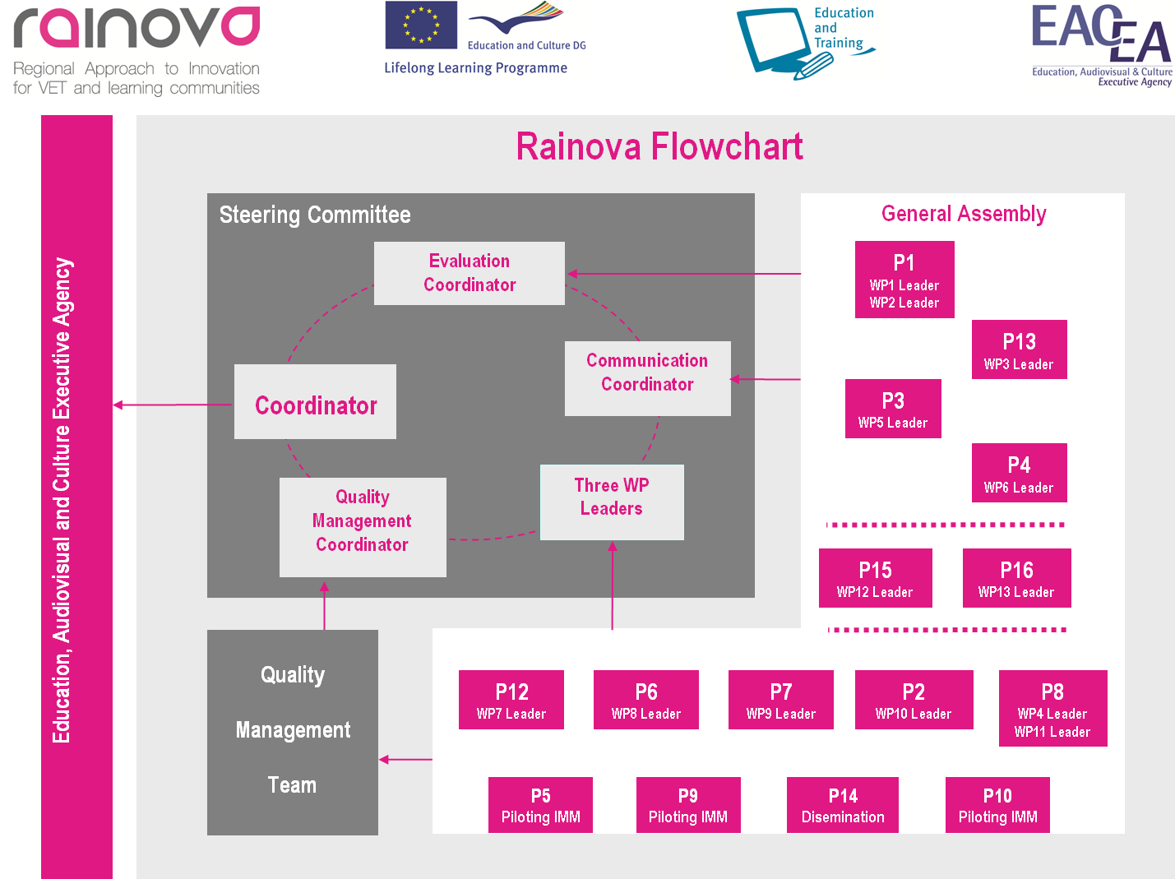

At the highest level of the project management is the Steering Committee (SC), chaired by the Coordinator and consisting of a Quality Management Coordinator, an Evaluation Coordinator and one Representative from four of the partners, one of them will be the Responsible of Communication (to be decided in the Kick off meeting). The SC will have overall executive level responsibility for the project, and will meet at least twice each year. The SC will be consulted for policy, strategic and economic decisions.

Technical management of the project will be carried out by the Coordinator (CO), and it will be done in conjunction with the WP leaders, who will be responsible for the day to day technical management at their own sites.

The day-to-day project management and progress monitoring will be performed by the Coordinator with the assistance of the Quality Management Team (QMT). The Quality Management Team will be in charge of the daily administrative work and logistics.

The General Assembly …..

3.2 Management responsibilities

3.2.1 The Project Coordinator (CO)

The Coordinator is the focal point for all technical and administrative content of the project, and for ensuring that the guidelines established by the SC are adhered to. The Coordinator’s responsibilities will be to:

- administer the Agency financial contribution regarding its allocation between beneficiaries and activities, in accordance with the Grant Agreement and the decisions taken by the consortium. The coordinator shall ensure that all the appropriate payments are made to the other beneficiaries without unjustified delay.
- keep the records and financial accounts making it possible to determine at any time what portion of the Agency financial contribution has been paid to each beneficiary for the purposes of the project.
- inform the Agency of the distribution of the Agency financial contribution and the date of transfers to the beneficiaries.
- review the reports to verify consistency with the project tasks before transmitting them to the Agency.
- monitor the compliance by beneficiaries with their obligations under the Grant Agreement.
- chair the Steering Committee meetings.
- manage the Agency Contract and Consortium Agreement.
- ensure that the content of deliverables, reports and publications produced by the project meet the requirements.
- ensure coordination of the project with the aim that the project maintains relevance against the programme objectives and progress made by international research.
- summon partners to the Steering Committee.
- constantly monitor project progress and report potential problems to the Steering Committee.

3.2.2 The Quality Management Team (QMT)

The Quality Management Team will work in close cooperation with the Coordinator, and take responsibility for the administrative and day-to-day management for supporting and realising the coordination tasks, including:

- providing administrative support to the Coordinator and assist individual project partners on specific administrative issues.
- providing reporting administration – creating templates and instructions for the partners in order to facilitate the gathering of information and reporting input
- providing assistance to budget control and financial follow-up - Establishing and maintaining financial records.
- assisting the Coordinator in the financial management with the collection of information from the partners, the consolidation of management reports, the monitoring of expenses against budget allocations, the consolidation of financial summary sheets, etc.
- supporting the setting up and maintenance of a project internal website as an infrastructure to foster efficient remote collaboration, information exchange and sharing by the project partners.
- supporting the setting up of an external website and a brochure to enhance dissemination efforts.
- supporting the setting up of a dissemination plan, in coordination with all partners.

3.2.3 Workpackage leaders

For every workpackage a leader is appointed. Each leader will be in close contact with the coordinator, will lead the workpackage team, and will be responsible for:

- The execution of the overall technical objectives of their WP.
- Technical and scientific issues and the project work at the partners’ site.
- Local task coordination.
- Timely production of reports and results.
- Management of the work package and the activities planned in the WP tasks.

Every Workpackage Leader will be in touch whenever needed. These meetings will allow for technical discussions regarding the Workpackage to be carried out, for internal decisions, and for the collection of intermediate documentation.

3.2.4 Description of a Partner's tasks:

- Collaboration in the several work plans and in the quality and plans.
- Investigation in parallel of technological changes that affect in the sector and implied processes.
- Selection of key processes (affected by the changes and common to other sectors) and identification / definition of associate competences.
- Collaboration in the preliminary design of the final product
- Experience piloted in companies of the different countries.
- Validation of the final product and launching
- Review the prototype and contribute with suggestions.
- Translate the final products in to his/her national language.
- Edition and valorisation the results of the project.
- Participation in the transnational meetings.

3.3 Decision making

3.3.1 Steering Committee

The Steering Committee will be constituted by the project Coordinator, the Quality Management Coordinator, the Evaluation Coordinator, the Responsible of Communication and three members elected from the rest of the partners.

The Steering Committee will carry out the following tasks:

- Coordinate the project
- Coordinate the quality
- Coordinate the evaluation
- Coordinate the communication

3.3.2 General Assembly

The General Assembly (GA) is the high-level decision-making body of the consortium, with the authority to decide on scientific, knowledge and administrative matters. Decisions of the Assembly will be binding on all partners.

The GA will have decision-making and arbitration authority in the following subject matters:

- Operation of the Consortium.
- Strategic decisions in relation to milestones of the project.
- Decisions on exclusion/withdrawal of a partner.
- Advising on deadlock situations occurring in the project and not previously resolved by the Coordinator.
- Decisions on measures to be taken against a defaulting partner, and suggestions to any new entity to replace the defaulting partner.
- Decisions on measures to be taken in case of default by the Coordinator, and the possible appointment of a new Coordinator.

4. Communication

Three different kinds of communication are distinguished: internal, external and towards the Agency.

To facilitate the collaborative work within the Rainova project, the use of various time and cost-saving tools and standards is part of the project.

4.1 Rainova internal web site

The aim of the Rainova internal web site is to support remote collaboration by offering a common space were the project partners can share and exchange information, communicate with each other, and work together on project documents. Each partner organisation can access the website with a user name and password.

Adastra is responsible for creating, maintaining and manage the website, and the team will regularly update the information on the site throughout the project.

The Rainova private web tool will be hosted at xxxxxxxx and its infrastructure is based on the commercial platform xxxxxxxx.

The project information to be found on the Rainova web site includes:

Folders in the internal  website | Content
Action Items | A list of the project Action Items currently in process or recently completed.
Consortium details | Contains the complete consortium contact list, as well as the various mailing lists used within the Rainova project.
Project documents | This folder contains the latest versions of all Rainova project documents, such as the Grant Agreement, Consortium Agreement, Description of Work, etc.
Agency Documents & Guidelines | Documents and guidelines published by the Agency relevant for the Rainova project.
Templates | Templates for all relevant documents and reports.
Project meetings | Contains all details from past and upcoming project meetings: presentations, agenda, minutes, travel info etc.
Deliverables & Milestones | This folder contains an overview of the Deliverables and Milestones of the Rainova project, as well as all submitted documents.

The Rainova internal website has the following features:

- Publishing and structuring information through creation of web pages, easy up/downloading of files and good integration with MS Office.

- Easy finding of information through a powerful search tool, site map and page index
- Communicating with other project partners at forum or chat tools as well as by email notification
- Organising the common work with the other project partners by document version management tool.

The detailed information on the project internal website can be found in the Handbook to Internal Project Website, prepared by XXXX. The website map can be found as an appendix to this document.

The website is a private space and the access rights are managed accordingly. There are three access levels for the workspace: reader, author and manager. These access rights can be redefined for each room:

- A Reader can only read the content and may not add to or edit the content
- An Author can add to the content by creating pages or any other elements but may not edit what the others have created without permission
- A Manager owns all rights to create, move, delete or modify the content, as well as the role of the members. Adastra is the manager of the Rainova Internal Website.

4.2 Public website

The public project website is the public image of the project. It is used to share the information (news, events, brochures...) produced throughout the project. It provides complete external visibility and a permanent showcase of the project, since it contains general information on project goals, scope, focus and work progress as well as on consortium partners.

The website will mainly provide information sharing capabilities, and it is not intended to offer services that have complicated business processes. The main objective of the website is to create a venue for all individuals, organisations and institutions who are interested in the project.

The public website is part of the planned Dissemination activities, and thereby included in WP4 and WP6. Deliverable 9.1 Public Website and Project Brochure is under the responsibility of Adastra, and the website is already available, at the address http://www.Rainova-project.eu/

Some information about Rainova project can also be found at ADAM portal:
http://www.adam-europe.eu/adam/project/view.htm?prj=8497&prd=11

4.3 Distribution lists

The Rainova project has a small number of partners. Therefore, the mailing list mostly used is the one including the consortium as a whole, Rainova@rainova.eu. Through this list all consortium partners are informed at once and this will help to avoid misunderstandings and information lost.

In addition a mailing list has been set up for the members of the RAINOVA General Assembly, RainovaGA@rainova.eu. There is also an e-mail address for the RAINOVA Quality Management Team, RainovaQMT@rainova.be. The Quality Management Team will make sure that this list always contains the relevant team members from Rainova, which means the address, can be used throughout the project, despite potential changes in staff members.

4.4 Teleconferencing

Teleconferences with all consortium partners, or smaller groups of partners, can be scheduled throughout the project if needed. The conference calls are aimed to keep partners constantly informed on the ongoing issues in the project and boost the cooperation.

4.5 Dissemination policy

With regards to the dissemination activities, the following rules will be followed:

- In order to facilitate the identification by the public and the Agency, all dissemination materials (e.g. publications, websites, etc.) referring to the project will contain the following sentence:

“This Project is partially funded under the European Community's Lifelong Learning Programme (LLL/2012-2014), grant agreement n° 2011 - 4134/001 - 001.”

- The project logo should always be included in all dissemination materials, including the public and internal websites, articles, brochures, posters etc. If possible, also the EACEA logo should be included.

- It is necessary to always acknowledge the EC funding within the project dissemination, which is why the EC flag should be included in dissemination material.

- In case several logos are included, e.g. the logo of partner’s organisation, other sponsors etc., they should all be of about the same size – there should not be a large differences for example by making the host organisation's logo bigger than the others

- For reports, publications etc., containing results from the Rainova project, the following disclaimer should be added included (in accordance with the Rainova GA): “The research leading to these results has received funding from the European Community's Lifelong Learning Programme (LLL/2011-2014) under grant agreement n° 2011 - 4134/001 - 001.”

- Reports, products and results information will be displayed at the following addresses:

http://ec.europa.eu/eve/
http://www.adam-europe.eu/adam/homepageView.htm

- The home page of the website should contain the generic European flag and the EACEA logo which are available in electronic format at the Europa website (logo of the European flag: http://europa.eu/abc/symbols/emblem/index_en.htm.
Logo of the EACEA: http://ec.europa.eu/xxxxxxxx).
The area of activity of the project should also be mentioned.

Publications

When publications are made it must be ensured that there is no conflict of interest with the other project partners. Therefore, a policy for a publication procedure has been adopted.

A project partner, considering publishing results in a scientific journal, should:

- Discuss this intention with the other partners and keep the Coordinator and Quality Management Team informed. If foreground or background to be published belongs to other participants, seek their prior approval.

- Carefully check the compatibility of the project Grant Agreement, with any publication agreement that is envisaged to be signed;

- Inform the publisher of the obligations resulting from the Grant Agreement. A contractual provision could be inserted in the publication, confirming the agreement to take this into account:

"The publisher agrees that the author retains the right to provide the Agency for publication purposes with an electronic copy of the published version or the final manuscript accepted for publication."

The publisher will also have to be made aware of the statement of financial support (see 7.1 above) which must be mentioned.

Communication with the Agency

The project Coordinator (CO) is the official interface with the Agency, on behalf of the consortium. All communication regarding the project, coming from within the consortium or from the Agency shall go through the Coordinator.

5. Project Meetings

The following procedures mainly aim at minimizing the overhead and facilitating the procedures for standard events.

The project calendar includes several meetings, each with its own scope. Good practices for the meetings are given in these guidelines as well as the definitions of the responsibilities for the meetings.

The following sections describe the procedures concerning: types of meeting, organisation of the meetings, responsibilities of participants, agenda and minutes, etc.

5.1 Types of meetings

During the project several different types of meeting will be held, each with its own scope. Periodic meetings are:

- Kick of Meeting – will be held at the beginning of the project.
- Project Meetings – will be held approximately every 3-4 months throughout the project, often in connection to another project event, such as the planned end-user workshop etc.
- Steering Committee Meetings – will be held at least once a year, ideally in connection to a Project Meeting.
- Quality Management Team Meetings – will be held in connection to the Project meetings.
- Information Dissemination events: preparation of conferences, workshops, etc.
- Final Conference -

5.2 Meeting organisation

The following principles have been adapted for the meetings:

- The following expenses will be covered by the hosting organisation:

- Conference room rent and facilities (screen, projector etc).
- Catering/food during the day as well as coffee/tea refreshments during the day.

- Participants. When appropriate, small meetings will be chosen rather than large ones. It is advised not to invite people who are not directly concerned with the subject of the meeting.

- Planning and logistics: Meeting dates should be chosen sufficiently in advance to ensure the possibility for all participants concerned to attend. If possible, meetings with different purposes should be combined to save both travel time and money. A detailed description of travel information should be provided (not just the address but details of train, metro, taxi, schematic map of the meeting location, telephone number of someone in contact with the meeting coordinator), as well as a recommendation on hotels.

Meeting preparations and logistics are under the responsibility of the hosting partner organisation, in collaboration with the Quality Management Team (QMT). All meeting information will be distributed to the partners by mail, and it will also be made available on the internal project website.

- Each partner will be responsible for his/her own travel expenses to and from the meeting and accommodation during the meeting.
- Each of these meetings should be well prepared and it will be documented afterwards by minutes summarising the results, and by a list of Action Items agreed upon during the meeting. The minutes and Action Items list are produced by the Quality Management Team, in cooperation with the coordinator.
- Particular attention must be given to the follow-up of the meeting: distribute the minutes quickly, check commitment on decisions and actions with absent partners, check that decisions are respected and action items executed.

A list of the project meetings is appended to the document (see Appendix 1 - Timeline and Work Plan) and is available on the web site of the project.

5.3 Responsibilities of the meeting participants

Each participant to a meeting should contribute to the meeting preparation and follow-up by providing:

- Working documents: normally discussion papers which list the main subjects to be discussed during a meeting. As far as possible, these papers should be distributed in advance and not during the meeting itself, in order for the partners to get prepared for the meeting.

- Contributions to the agenda.

- Preparation of presentations.

Partners will contribute as well to the definition of meeting objectives and the preparation of decisions.

5.4 Meeting calling notice

Each project meeting must have a structured agenda, clearly showing the issues to be discussed during the meeting as well as the time frames foreseen. The meeting calling notice, including the agenda, should be distributed in advance (minimum two weeks before the meeting), to inform the participants about the topics to be discussed and to give them the possibility to suggest changes to the agenda. In case of modifications the document must be re-circulated.

The meeting agenda will be prepared following the “Meeting calling notice” template available on the internal website and appended to this deliverable. The regular meeting calling notice contains some standard details:

- Date and place of the meeting as well as local point of contact
- List of attendees
- Purpose of the meeting and expected results
- Pre-requisite from participants
- Meeting agenda for every meeting day including time for breaks and lunch
- Travel information (accommodation, maps, transportation etc)
- Remarks on previous minutes, action points or any meeting specific subject will be added if appropriate

5.5 Minutes

The minutes of each meeting will be drafted by the host organisation and later reviewed and if needed modified by the Quality Management Team (QMT) before the draft is distributed to the partners. Draft minutes must be circulated within two weeks after a meeting, and will be subject to approval by all partners. The minutes shall be considered as accepted if, within 7 calendar days from sending, no member has objected in writing to the Coordinator with respect to the accuracy of the draft of the minutes.

An important part of the minutes is the Action Items List. Updated versions will be circulated whenever necessary, and the latest version will always be available on the internal project website.
The minutes will reflect major issues which have been discussed. All minutes of periodic meetings will have the same structure, and should contain the following information:

- Meeting date and place.
- List of participants (indicating absentees).
- Objective(s) of the meeting (in brief).
- Actual agenda.
- List of documents distributed during the meeting with reference to the author.

For each point addressed as part of the agenda:

- Summary of discussion (if relevant).
- Decision(s) made.
- Open issues.
- Action items.
- Supporting information (if relevant).
- Information on the next meeting (if appropriate).

6. Document management

During the lifetime of the Rainova project, many documents will be produced. Some simple rules should be followed in order to facilitate the management of information produced within the project, and to ensure consistent document presentation and management.

Responsibilities or ownership of documents are specified in this plan, as well as other general rules of formats and instructions on the level of confidentiality of the documents.

6.1.1 General rules

Document owner

Even if a document contains contributions from many partners, it should have one “Author” who leads the production of that document, makes a proposal for its content and the required contributions and consolidates the drafts.

The responsibility (or authorship) is defined as follows:

Document | Responsible
External deliverable | The representative of the partner identified as responsible in the DoP
Any other technical report | The partner issuing this document

The production of management reports and administrative documents for the Agency is under the responsibility of the Coordinator, who also validates the reports before submission. During the administrative process of producing such documents the Coordinator is assisted by the Quality Management Team.

In any case, the responsibility for a document should be clearly identified as part of the work planning tasks for each working period.

Multiple contributors

The official management documents which are to be submitted to the Agency (e.g. deliverables, management reports) require contributions from many partners and the commitment to firm deadlines.

To produce such a document, a template indicating the required contributions will be produced by the Quality Management Team. When the deadline for submission of a particular document is approaching, the Quality Management Team will distribute this relevant template to the concerned partner(s), and the template will also be found on the internal website.

Regarding deliverables the template will be sent to the partner responsible for the deliverable in question. It is then up to this partner to communicate with any additional contributors, in order to assure complete input for all involved parties.

To ensure quality of the entire document, it is crucial that all contributors respect the deadlines indicated.

Language to be used

With UK English being the official language for Rainova, all documents must be written in English. As not all partners are English native speakers, a simple language should be privileged.

Note: When many contributors from various european countries contribute to the same document or deliverable, the style and vocabulary of the final document might be very heterogeneous. A careful final revision and English checking is expected, in particular for deliverables which will be submitted to the Agency.

The language and spelling should follow the UK English of MS Office.

Computer file formats

To ensure document compatibility, the following file formats should be used:

- WORD version Microsoft Office 97-2003 (.doc) for documents.
- EXCEL version Microsoft Office 97-2003 (.xls) for spreadsheets.
- PowerPoint version Microsoft Office 97-2003 (.ppt) for overhead slides.
- PDF for consolidated releases of project documents (.pdf).

6.1.2 Document format

The Rainova partners will use a standard document format (styles, pages layout, basic content structure definition, etc.) and filing codes for all documents produced in the project.

Document templates

Templates for Rainova project documents are prepared by the Quality Management Team and made available on the Rainova internal website: Word templates for technical reports, including deliverables, etc.

In addition, a PowerPoint template for presentations will be provided too.

The document templates include the project logo on the cover page and specific sections to be filled to make the document compliant with the Rainova rules and “look and feel”. The template defines the layout of the cover page and the internal pages, including required basic information fields and MS Word styles to be used.

The cover page of a Rainova document contains (see the implementation of the present document):

- EC flag, EACEA and Rainova project logo.
- The project acronym and full name.
- The document title.
- The contract no (517752-LLP-1-2011-1-ES-LEONARDO-LNW).
- The issuing date of the present version of the document.
- Author organisation.
- The confidentiality level (see codes below).
- The filing code (see codes below).
- Related items (optional field to be filled in if the reader should have knowledge of the content of another document in order to understand the present one).
- A history field indicating the releases, dates, reason of change, status and distribution (see codes below). For official releases this history will be deleted.

The internal pages will contain in the header:

- Document title
- The project acronym
- Date of current release

And in the footer:

- The project acronym
- © Rainova Consortium
- An indication in case the document is confidential
- The page number

It is mandatory to use these templates for all Rainova documents. Updated templates will be available for downloading on the internal website.

Document coding

Each document will be filed with a unique filing code, regardless of the file names and referencing conventions that each partner might use in local archives.

The code is defined as follows: Rainova_TTT_AAA _vX_DATE_PP

Where:

TTT is the type of document:

- Short reference to the document type
- Dxx=Deliverable (for deliverables the xx represents the deliverable reference number according to the DoP);

AAA is the author (issuing company/entity), i.e. the abbreviation used in the DoP

vX is version number (v1, v2 etc) – is managed by the document owner who consolidates all the
inputs

DATE for the preparation of the version

PP is the initials of the person responsible for the version

Examples:

- Rainova_KOM-minutes_TKNIKA_v3_20-01-2012_JLFM.doc indicates this is the third version of kick-off meeting minutes, issued by TKNIKA on January 20th 2012, by JL Fdez. Maure.

- Rainova_D1_IKASLAN_v2_21-12-2011_ST.doc is the second version of Deliverable D1, issued by Ikaslan on December 21st 2011, by Samuel Triguero.

Level of confidentiality and dissemination

By default, each document created within Rainova should include “©Rainova Consortium” in the footer. Corresponding legal mentions are included in the document templates and should not be removed, unless a more restricted copyright applies (e.g. at company level).

In the Rainova Detailed Description of the Project (DoP), the deliverables listed in G.2 are defined with a specific dissemination level. This dissemination level shall be mentioned in the document (a specific place for this is included on the cover page of the Rainova document template). The various dissemination level indicators are defined by the EC (PU, PP, RE, CO).

The dissemination level should be defined for each document using one of the following codes:

PU = Public
PP = Restricted to other programme participants (including the EC services)
RE = Restricted to a group specified by the Consortium (including the EC services)
CO = Confidential, only for members of the Consortium (including the EC services)

It is possible to create later a public version of (or parts of) a restricted document, under the condition that the owners of the restricted document give their written consent to release this public version. In this case, a new document code should be given so as to distinguish between the different versions.

Exchange of confidential information

The identification of confidentiality level mentioned above has the aim to indicate clearly to the partners who is authorised to receive and read the document, so as to handle the documents with the appropriate care.

For internal information exchange and for the delivery of documents released to the Agency, the partners will use email, mailing lists and the internal project website.

The access to the internal website is controlled by an individual login/password; however the server will be hosted on a shared platform operated by a commercial Internet Service Provider.

The mailing list server will be hosted on a server operated by XXXXX, and located in standard business offices.

Document archive

The project archive stores copies of all officially distributed documents such as deliverables, reports, financial statements, meeting minutes etc. The Quality Management Team administers the project archive and keeps track of all official releases of the documents produced by the Rainova partners.

The partners have the responsibility to send electronic copies (or paper copies in case no other version exists) of the documents to the Quality Management Team, or to store the document directly on the Rainova internal website (in this case, this should be notified to the Quality Management Team). All consolidated technical documents will be stored on the project private website in the folder related to the content of a concrete document.

Please refer to Annex 3 for a site map indicating the file locations on the private website.

7. Production of deliverables

The project deliverables constitute documentation of project results, and are indicators of the project progress. The Rainova consortium has defined a list of deliverables that are contractually bound to be submitted to the Agency. These deliverables are listed in section “Apendix 1 – Timeline and Work Plan”. The Rainova deliverables are strictly tied to the breakdown of the work into work packages that constitutes the structure of the project. Deliverables are generally technical documents which report the major project results.

Each deliverable tackles a specific subject, and has an owner responsible for the production of the document. The owner of the deliverable is also responsible for the coordination of eventually required partner contributions.

For deliverables the partner responsible for the production of a deliverable is defined in section “G.3 Consortium partners involved and resources required to complete the work package” of the DoP. Normally, the WP leader acts as “Deliverable leading beneficiary”. However this might not be the case for all deliverables.

Before launching the production of each deliverable, the deliverable owner should follow the deliverable template, available on the internal website. The quality check procedure should also be followed, including review of the deliverable by the consortium partners and the Coordinator.

The deliverable template must define a draft structure of the future deliverable, and therefore it will contain a clear indication of:

- Table of Contents
- The person responsible for the deliverable (Deliverable Leader)
- Persons in charge for the preparation of each chapter/section
- The deadline for the deliverable development (see also general flow chart below):
- Submission of contributions
- Production of the first draft (version 1)
- Internal review (partners’ comments)
- Production of further version/s of the draft
- Quality check
- Final validation and submission to the Quality Management Team, for further submission to the Agency.

Upon receipt of the inputs from the different contributors, the deliverable leader should merge them into a single document (following as much as possible the structure defined in the template). This first draft should then be circulated to reviewers and to the Coordinator.

Each reviewer will check the consistency with the plans and give their feedback and/or approval. This iterative procedure will be repeated as necessary, until approval is given by all involved partners. A final draft should then be prepared by the deliverable owner.

When the final version is consolidated the Quality Management Team will then take care of the final formatting if needed, and of the logistics to produce the required number of copies and send them to the Agency.

The deliverable leader should take into account realistic timings for the submission of inputs, in order to meet the established date for its submission to the Agency.

Partner Responsible
WP Leader

Quality Management Team

Coordinator

Deliverable issued
Technical approval

Quality assessment

Formal assessment

7-1 Deliverables production process

7.1.1 Deliverable structure

A deliverable can be divided up into four main parts:

- Introductory pages: The project standard cover page (see section “Document templates”) and the table of contents.
- A summary: This section should be a synopsis, or general overview, summarising the content of the document.
- The main part of the deliverable: containing the planned technical information.
- A concluding section, which may comprise:

  - A conclusion;
  - A bibliography: a list of documents, publications and other key references relevant to the deliverable;
  - A glossary: a glossary of all abbreviations used in the document
  - Annexes with additional information.

In case the actual deliverable is not a document, but a prototype, a demonstrations, etc., it needs to be documented with a written document, e.g. a user manual, specifications or other appropriate documents.

7.1.2 Internal review and quality check

Both the form and the content of the deliverable should be reviewed before submission to the Agency, sufficiently in advance to allow for proof reading, feedback and updates.

- Form: The purpose is to verify the level of quality of the deliverable (get rid of major inconsistencies). Criteria will relate to the style, spelling, consistency of the language, conformity with standard structure (cover, table of contents, summary, main text, glossary, bibliography) etc.

- Content: The purpose is to verify that the technical content is of professional quality and meets the expectations. Criteria will relate to the document structure, completeness of the description, levels of details, technical correctness, references, etc.

The Quality Management Team will assess the quality of the document, while the reviewing partners and the Coordinator will review the deliverable regarding its technical content.

Time frame for deliverable production

Each deliverable has a due date, the month it should be completed, which is defined in the Work Plan. At the end of this period the deliverable must be submitted to the Agency.

In order to assure the timely submission of deliverables, the accepted timeline should be followed.

The partners are highly encouraged to aim for a shorter process, in order to avoid delays in the production of deliverables. The Quality Management Team will send an e-mail to the responsible partner with a reminder of an upcoming deliverable due date, also containing some brief instructions of the process, as well the deliverable template.

Deliverable acceptance

Formal acceptance of the deliverable by the Agency corresponds to the terms of the contract within 45 days after submission, pending a final approval at a project review or audit. If deliverables are not accepted, the consortium might be asked to perform additional work and the payment of Financial Statements could be delayed. It is therefore in the interest of all to produce deliverables of high quality and in the required format.

8. Reporting and progress monitoring

The Agency performs control of the project progress essentially through the following three means:

- Deliverables
- Intermediate Reports
- Project Reviews

The internal reporting will be implemented through Intermediate Reports (IRs) which will consist of update on technical activities as well as resource consumption information.

The information provided will be used to detect eventual deviations by comparing actual work results to a set of indicators, used to monitor progress defined in the planning stage of the project.

The management and quality control procedures for the production of deliverables and Agency project reviews are described in dedicated sections.

8.1 Intermediate Reporting

The intermediate reporting will be used to track project progress and identify rapidly problems and risks, in order to enforce pro-active management. It will also help to address the requirements for the periodic reporting and to meet the short contractual deadlines.

The intermediate reporting will gather information on:

- Objectives for the period.
- Technical progress and significant achievements during the reporting period for each workpackage.
- Main activities carried out during the period.
- Status of milestones and deliverables.
- Problems encountered, risks identified.
- Deviations encountered and contingency plans.
- Dissemination activities during the period.
- Resource consumption.
- Results achieved.
- Meetings attended, etc.
- Plans for the coming period.

Procedure:

- A template for the IRs will be available on the internal website.
- The template is to be filled in the week following the end of the each period by each partner.
- The Coordinator and the Quality Management Team will ….

8.1.1 Resource consumption

Also resource consumption reports will be provided through the same IRs template. The resource consumption will be tracked per partner effort spent per WP and expenditures according to the categories identified in the EC financial statement form.

The DoP contains the initial planning for the total project duration. A more refined Work Plan has been performed by the Quality Management Team, in order to prepare accurate planning and indicators for the Rainova project. The Person Months (PM) allocated to every partner in every task have been translated into the provisional planning of their resource consumption per quarter, with regards to the timeline of the specific tasks a partner is involved in. The actual costs will be compared to the budget plan and the resource consumption will thereby be controlled.

The IRs template prepared by the Quality Management Team will contain tables for collecting the data on PMs and EURO spent by the partner over the last 3 months period. The Quality Management Team will copy these figures into a budget follow-up file for each period and consolidate the figures at the integrated project level.

8.1.2 Progress monitoring

The intermediate reporting procedures described above will provide relevant information for monitoring the project progress. The information provided will be used to detect eventual problems by comparing them to a set of indicators defined in the Work Plan of the project.

Definition of indicators

Indicators have the aim to support the project Coordinator and Quality Management Team in their project planning and quality control tasks, and the management bodies in the decision making. As far as possible quantitative indicators should be defined since they have the advantage of being simple and clear.

Rainova will use a combination of different indicators:

- Technical indicators
- Resource indicators
- Performance and state-of-the-art indicators
- The Detailed Description of the Project contains work-package and task descriptions indicating the planned activities, responsibilities, contributions, results and milestones. This information will serve as indicators for the monitoring of the project progress. The feedback on the work progress will be provided by the work-package leaders through activity reports.
- Action Item Lists provide useful indicators for the shorter term. The Work Plan identifies activities at the work package and tasks level, but in technical coordination meetings at WP and SC level more detailed decisions will be taken on who is doing what and for when. At each meeting an Action Item List should be drawn up; these action item lists can then serve as indicators for monitoring of the work progress.
- A deliverable is not an indicator in itself as long as it is not established that the deliverable fulfils the technical objective it is deemed to represent. The scarce information in the list of deliverables in the DoP needs to be complemented with additional information that can be used as indicator to monitor progress and evaluate achievements. Therefore the production of deliverables is defined in more details in the Work Plan.

Overall responsibility

The information reported by the project partners will be consolidated by the Quality Management Team and made available to the consortium, both through e-mail and on-line on the project internal website. The Steering Committee is responsible for analysing the current project status and making decisions as needed.
The review of the consolidated status reports will be a standard topic of each Steering Committee meeting agenda.

In the case were a deviation from the plans and / or a reported risk might have a significant impact on the project performance, the Steering Committee will decide on corrective measures to be implemented. These corrective measures will be enforced through the WP leaders. In the case where the problem and corrective action would have an impact on the contract with the Agency, the Quality Management Team will be involved.

When reporting on problems or risks, the WP leaders should make proposals for corrective actions to be adopted by the Steering Committee. The Steering Committee will either confirm those or decide on alternative measures to be implemented, in particular in the case where there might be an impact at the project level.

In the case where an urgent action is required the Coordinator and the Quality Management Team should be informed immediately. In this case the Steering Committee should take a decision within 2 weeks, and – if there is no opportunity for a real meeting in this period - use electronic means to exchange views and take a decision on how to handle the case.

9. Financial management

The Financial Management Rules are laid down in Annex I (Description of the Action).

Financial Statements have to be produced periodically, and submitted through the Coordinator to the Agency. Payment handling involves the Coordinator receiving Agency contribution on behalf of the consortium.

The transfer of payments to each partner is under the responsibility of the Coordinator, and is carried out in accordance with the procedure and schedule defined in the Consortium Agreement.

9.1 General information

The following section sets out a number of financial rules applicable to the Rainova project.

Guarantee Fund: The Agency Guarantee Fund is a mutual benefit instrument to establish solidarity among project participants. The Fund is kind of insurance contact by the beneficiaries to guarantee the financial losses of the project. Every partner contributes to the Fund 5% of the maximum Agency contribution at the beginning of the project. At the end of a project, the money will be returned to the beneficiary or could be assigned to the payment of any debt due to the Community by the said partner under any obligation irrespective of its origin.

Actual Costs: Rainova is a cost-sharing contract, which is based on the actual costs incurred for the work under the project. No estimated, budgeted or imputed rates are allowed. Neither the Coordinator nor partner beneficiaries can make any kind of financial profit from their participation in this project. The fact that the Commission will make periodic payments for the costs claimed does not mean that these costs have been accepted. Costs can be considered as definitively accepted only after a Review or after expiration of a period of five years after the completion date or the termination of the contract.

Financial Contribution by the Contractors: As a rule, the Agency is only funding a part of the costs incurred under the contract. This means that the remaining part of the costs has to be financed by the contractors and Participating organisations from their own resources.

Indirect costs identification
There are four methods of indirect costs identification:

- Actual indirect costs for partners with analytical accounting system - in Rainova partners, XXX, XXX, XXX use the actual indirect costs method.
- A partner is allowed to use a simplified method of calculation of its full indirect eligible costs at the level of its legal entity if this is in accordance with its usual accounting and management principles and practices - in Rainova no partner uses the simplified method.
- A partner may opt for a flat rate of 20% of its total direct eligible costs – in Rainova XXX applies the flat rate method for their indirect costs calculation.
- Non-profit public bodies, secondary and higher education establishments, research organisations and SMEs, which, due to the lack of analytical accounting, are unable to identify with certainty their real indirect costs for the project, may opt for a flat-rate of 60% of the total direct eligible costs – in Rainova partners XXX, XXX and XXX.

Time sheets: All Contractors must keep a record, on a regular basis, of all the hours spent on the project. The actual number of hours spent on the project must be stated in the progress reports and in the cost statements. The absence of time sheets kept by the Contractor may make it impossible for the Commission to contribute to the costs claimed for labour.

Justification of Costs: All the documentation to support and justify the costs reported must be kept in order and made available for audits. Contractors have the obligation to justify all the costs and the hours claimed for the project.

9.2 Preparation of Financial Statements and Certificates

All consortium partners will submit their Financial Statements (Form C) periodically (Month 12, Month 24 and Month 30)

The following procedure will be implemented for the preparation of the Financial Statements:

- The EACEA forms for the compilation of the Financial Statements are provided via an online tool called FORCE: https://webgate.ec.europa.eu/FormC
- Each partner is expected to register via ECAS: https://webgate.ec.europa.eu/ecas/help.jsp.
- For each beneficiary the Forms C contain the necessary ’intelligence’ to ensure that:

- The requested Agency contribution does not exceed the maximum that can be requested, taking into the applicable reimbursement rate for the different activities and your cost model/indirect cost methodology
- Only those activity columns can be filled in.

- Each beneficiary can submit his own Form C to the coordinator, but a beneficiary cannot submit directly to the Commission.

- The Quality Management Team will give appropriate instructions to all partners as to deadlines and procedures:

- One month before the end of the reporting period the Quality Management Team will remind the partners that they will have to submit their Financial Statements.
- The partners should provide their Financial Statements electronically not later than three weeks after the end of the reporting period.
- The Quality Management Team will verify the correctness of the costs against known the Agency rules and against the Partner's budget. The Quality Management Team will then consult the Coordinator, in order to verify that the reported costs are reasonable in view of the work reported in the progress report.
- Once the electronic versions of the Financial Statements are verified, the coordinator will submit the Form Cs
- Once the Form Cs are verified, the Quality Management Team will ask the partner to provide three originals of the Form C with signatures - no photocopies accepted! Copies of eventual subcontractor's invoices must be attached.
- In case a partner does not submit the Financial Statements in time, the Project Director can decide that no Financial Statements for his/her organisation will be included in the submission to the EACE and that consequently the partner will not receive any funds, or will have to wait until the next period. This is to avoid that payments to all partners will be delayed because of the delay from one partner.
- Finally, the Quality Management Team will gather the partners’ Financial Statements and send the entire set (if requested along with the Certificates on Financial statement - see section below) and the due reports to the Agency within 45 days after the end of the reporting period.
- Note: the Financial Statements will not be processed by the Agency until the corresponding Intermediate Report and Financial Reports are received.

The Agency will pay the Community financial contribution within 105 days following the reception by the Agency of the reports related to each reporting period. Where no comments, changes or substantial corrections to any of the project activity reports or Financial Statements are required or where the Agency approves the report, the Agency shall make the appropriate payment.

The Agency should send a written reply to the consortium after reception of the reports. The Agency may reject reports and deliverables even after the time-limit for payment.

10. Risk management

Risk management is a procedure to assess and mitigate events that might adversely impact the project, in order to increase the likelihood of success.

Risk management deploys methods for identifying, analysing, prioritising, and tracking risk drivers.

10.1. Definitions

Risk

Risk is a measure of the inability to achieve overall project objectives within defined cost, schedule, and technical (performance and quality) constraints and has two components:

- Probability of failing to achieve a particular outcome
- Consequences of failing to achieve that outcome

Risk events could become problems in the development of the expected results and their dissemination.

Type of Risk

- A Technical Risk is the risk associated with the evolution of the project development and results affecting the level of performance necessary to meet the requirements of the DoP.

- A Cost Risk is associated with the ability of the project to achieve its cost objectives as determined in the DoP.

- Schedule Risks are those associated with the adequacy of the time estimated and allocated for the development, production, and fielding of the system. Two risk areas bearing on schedule risk are

Risk Ratings

This is the value that is given to a risk event based on the analysis of the likelihood and consequences of the event. Risk ratings of Low, Moderate, or High shall be assigned based on the following criteria:

- Low Risk: Has little or no potential for increase in cost, disruption of schedule, or degradation of performance. Actions within the scope of the planned project and normal management attention should result in controlling acceptable risk.

- Moderate Risk: May cause some increase in cost, disruption of schedule, or degradation of performance and quality. Special action and management attention may be required to control acceptable risk.

- High Risk: Likely to cause significant increase in cost, disruption of schedule, or degradation of performance and quality. Significant additional action and high priority management attention will be required to control acceptable risk. This type of risk may be subject to a report to the Agency.

10.2. Risk Management and Responsibilities

The Rainova Coordinator is the overall risk manager and responsible for tracking efforts to reduce high risk, combine risk briefings, reports, and documents as delivered by the WP leaders and required for project reviews by the Agency.

The Quality Management Team assists the Coordinator with maintaining this risk management measures, provisioning and maintenance of risk information forms, and accounting the overall risk status.

The Work Package Leaders are responsible for the risk assessment within their work packages, which includes identification, analysis, handling, information (in case of moderate or high risks), monitoring, and tracking efforts to reduce low and moderate risks.

10.3. Risk Management Process

Risk Assessment

Risk assessment includes the identification of critical risk events, which could have an adverse impact on the project, and the analysis of these events/processes to determine the likelihood of occurrence/process variance and consequences.

Risk assessment is an iterative process. Each risk assessment is a combination of risks identified/analysed in the previous phase and the identification/analysis of risks on current milestones according to the DoP.

Risk Identification

Risk identification is the first step in the assessment process. The basic process involves searching through the entire project plan to determine those critical events that would prevent the project from achieving its objectives.

Risks will be identified by all individuals in the project, particularly by the Work Package Leaders.
The basic procedure of identifying risks consists of the following steps:

- Understand the requirements and the overall project quality and performance goals.
Examine the operational conditions under which the values must be achieved by referring or relating to the DoP.
- Identify the processes and tasks that are needed to produce the results.
- Evaluate each task against sources of risk.

Risk Indicators

Following indicators are helpful for identifying risks (non-exhaustive list):

- Lack of stability, clarity, or understanding of requirements: Requirements drive the project development. Changing or poorly stated requirements guarantees the introduction of performance, cost, and schedule problems.
- Insufficient or inadequate resources: People, funds, schedule, and tools are necessary ingredients for successfully implementing a process. If any are inadequate, to include the qualifications of the people, there is risk.
- Communication is a critical success factor. Failure to provide (push) available information actively as well as to demand (pull) required information actively will both introduce considerable risk.

Risk Handling

After the project’s risks have been identified and assessed, the approach to handle each significant risk must be developed. There are essentially three techniques or options for handling risks:

- Avoidance - application of tasks in order to avoid the risk event
- Control - watch the environmental conditions for influences to an already assessed risk
- Transfer - application of tasks to set a risk to a lower level

Results of the evaluation process and how to handle shall include:

- What must be done.
- Level of effort required and estimated costs.
- Proposed schedule showing the proposed start date.
- Time phasing of significant risk reduction activities, including completion date.
- Their relationship to significant project activities and milestones.
- The person responsible for implementing and tracking risk handling measurements. (usually the work package leader)

Risk Monitoring

Risk monitoring systematically tracks and evaluates the performance of risk-handling actions.

It is part of the Coordinator’s and the Work Package Leaders’ function and responsibility and will not become a separate discipline.

Essentially, it compares predicted results of planned actions with the results actually achieved to determine the status and the need for any change in risk-handling actions.

11. Handling of changes

All the Partners should follow the recommendations and procedures defined in this Rainova Project Management and Quality Plan. However, there may be cases where decisions cannot be made or actions cannot be undertaken according to the defined rules.

Any major change in the rules and recommendations set out in the Project Management and Quality Plan will have to be decided in accordance with the following procedure:

- Proposal for actions and clear justification will be sent to the Coordinator and the Quality Management Team, defining risks and benefits for the project.

- If the Coordinator considers that the proposal for actions does not constitute any risks for the successful achievement of the project, he will accept the proposal.

- Ιf the Coordinator considers that there may a risk for the project, he will submit the decision to the GA members, who will be required to vote by a fixed deadline. Decisions will be made by a majority of 2/3 of the weight of the voting members present at the General Assembly meeting.

12. Conclusions

As mentioned earlier, a certain level of rigour when using these guidelines will reduce overhead, ease the management work for all partners and increase the efficiency and quality of the work carried out in the project.

All persons involved in the Rainova project tasks should understand and use this rules, standards and recommendations specified hereafter. In addition, with Rainova being a three years project, the individuals involved in project may change during the project lifetime. Clear procedures will assist newcomers joining the project and help them to become quickly operational.

The present document should be considered as a complement to all other important documents which should be used for reference while the project is running: the Grant Agreement and its annexes, the Consortium Agreement and the various Agency guidelines. A list of such key documents will be maintained by the Quality Management Team on the project private website.

The private project website should facilitate the cooperation and coordination of the Rainova project. All of the documents and tools previously described in these guidelines will be available through the website.

13. Appendixes

13.1 Appendix 1 – Rainova WORK PLAN

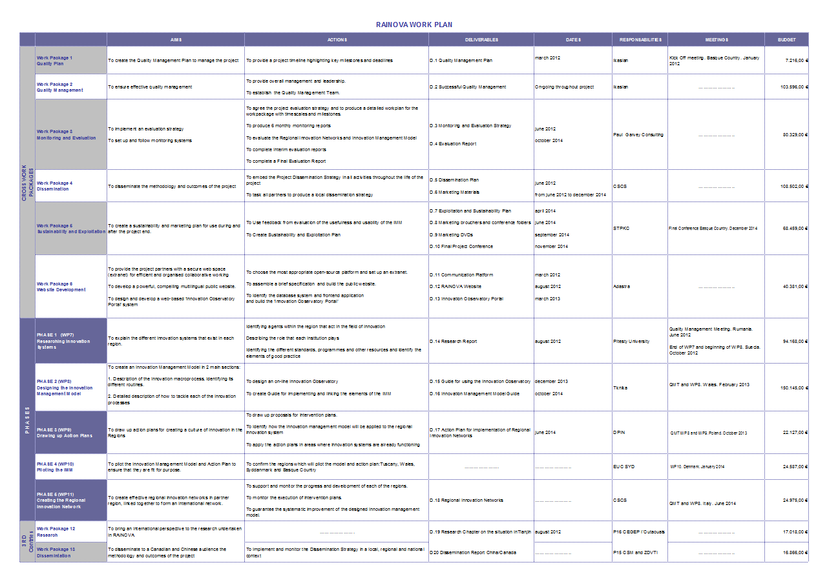

13.2 Appendix 2 - Intermediate Management Report

1 – Project status: Technical progress and achievements

Describe succinctly (max. 2 pages) the current status of the technical progress and the main achievements of the project during the reporting period. You can make sub-Sections for each workpackage if appropriate.

2 – Issues / deviations from the plan

Issue description  (explanation of the causes) | Action Items  (corrective actions envisaged)
Changes in the work planning | expected impact on the activities
Changes in the schedule of the  deliverables | new schedule - justification
Changes in planned milestones | new schedule – justification
Red Flags | if any
Any other issues or problems that might affect achievement. | discussion

Deliverables and Milestones for the reporting period
Month | Originally  planned | Current View | Actual

3 – Dissemination

3.1 Articles published, presentations at conferences, TV broadcasts etc.
List all dissemination material produced during the reference period and annex it to the report.

3.2 Web Sites
Describe any development concerning any project related website.

3.3 Other important information: Patent applications, guidelines standards, PhDs
Discuss also your contribution(s) made to standardisation bodies and contributions to special interest groups.

4 – Meetings Attended

Conferences or workshops attended (if organised by the project please indicate so)

Provide a list of attended meetings, where, for how long. Include also project meetings, listing participants. A clear description of the rationale of the meetings and of their relevance to the project’s objectives should be provided.

Partner |  | Date  (Start / End) | Meeting place | N° of persons | WP/Task/expected results/details

5 – Resources Employed/Expenditures

Present and discuss the effort for the reference period, per workpackage and per participant (expressed in Person-Months), comparing the planned effort (as specified in the GPF forms) with the actual resources spent (providing also the cumulative figures resulting from the start of the project) in the format specified in the excel spreadsheet enclosed.

The same type of information should be provided for the expenditures made by each partner, indicated in euro (euro x 1000).

Provide full justification for any significant deviations of actual expenditures from the original estimation (i.e. for any relative change of “spent” vs. “plan” greater than ± 20%).

6 – Others

Report any item of interest, such as name or address changes, responsibilities reassignment, or other.

13.3 Appendix 3 – Template Internal website site map

14. Glossary

Abbreviation / acronym Description

CA Consortium Agreement
CO Coordinator
CFS Certificate on Financial statement
D Deliverable
DoP Detailed Description of the Project
EACEA Education, Audiovisual and Culture Executive Agency
GA Grant Agreement
GA General Assembly
IRs Intermediate Reports
PMQP Project Management and Quality Plan
QMT Quality Management Team
SC Steering Committee
WP Workpackage
WPl Work Plan

